Desktop Wallet
# Source: AI Source: Provided by: [Data Path: Persons Table -> ID Column: 1, Name_En Column: Motasem Essam] -> From: [ChatGPT] on [1/21/2026]
A Desktop Wallet is a type of software-based crypto wallet installed on a desktop or laptop computer. It allows users to store, send, receive, and manage cryptocurrencies locally, giving them full control over their private keys (in non-custodial setups).

💻 Key Characteristics of Desktop Wallets:
# Source: AI Source: Provided by: [Data Path: Persons Table -> ID Column: 1, Name_En Column: Motasem Essam] -> From: [ChatGPT] on [1/21/2026]
- Installed Locally
  - Runs as a standalone application on Windows, macOS, or Linux systems.
- Private Key Storage
  - Keys are stored locally on the user's machine (non-custodial wallets).
  - The user is responsible for backups and securing their device.
- Supports Multiple Assets
  - Some desktop wallets are multi-chain, while others are coin-specific (e.g., Bitcoin Core for BTC only).
- Advanced Features
  - Many support custom fees, multisig wallets, staking, and hardware wallet integration.

🧳 Examples of Desktop Wallets:
# Source: AI Source: Provided by: [Data Path: Persons Table -> ID Column: 1, Name_En Column: Motasem Essam] -> From: [ChatGPT] on [1/21/2026]
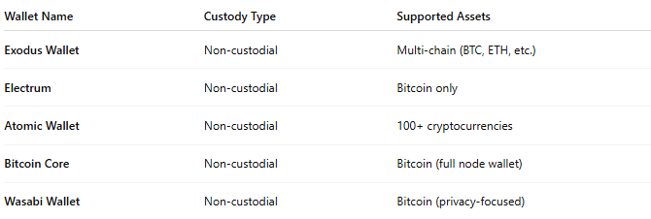

Wallet Name | Custody Type | Supported Assets
Exodus Wallet | Non-custodial | Multi-chain (BTC, ETH, etc.)
Electrum | Non-custodial | Bitcoin only
Atomic Wallet | Non-custodial | 100+ cryptocurrencies
Bitcoin Core | Non-custodial | Bitcoin (full node wallet)
Wasabi Wallet | Non-custodial | Bitcoin (privacy-focused)

🛠️ How It Works:
# Source: AI Source: Provided by: [Data Path: Persons Table -> ID Column: 1, Name_En Column: Motasem Essam] -> From: [ChatGPT] on [1/21/2026]
- User downloads and installs the wallet software.
- On first run, the wallet generates a key pair (private/public).
- User may be given a seed phrase for backup.
- Transactions are:
  - Signed locally using the private key.
  - Sent over the internet to the blockchain network.
- User can back up wallet files or the seed phrase for recovery.

✅ Advantages:
# Source: AI Source: Provided by: [Data Path: Persons Table -> ID Column: 1, Name_En Column: Motasem Essam] -> From: [ChatGPT] on [1/21/2026]
- Greater control over private keys and transactions.
- Generally more secure than web wallets (if device is well-protected).
- Often supports advanced features like:
  - Full node operation
  - Coin control
  - Privacy enhancements (e.g., CoinJoin in Wasabi)

⚠️ Disadvantages:
# Source: AI Source: Provided by: [Data Path: Persons Table -> ID Column: 1, Name_En Column: Motasem Essam] -> From: [ChatGPT] on [1/21/2026]
- Not portable – only accessible from the computer it’s installed on.
- Risk of loss if the device is compromised, stolen, or damaged without backup.
- Vulnerable to malware, ransomware, or keyloggers if OS is insecure.
- May require more technical knowledge than mobile/web wallets.

🧠 Best Use Cases:
# Source: AI Source: Provided by: [Data Path: Persons Table -> ID Column: 1, Name_En Column: Motasem Essam] -> From: [ChatGPT] on [1/21/2026]
- Users with medium to high crypto holdings
- People who want more privacy and transaction control
- Developers and advanced users
- Running full blockchain nodes

🆚 Comparison Table:
# Source: AI Source: Provided by: [Data Path: Persons Table -> ID Column: 1, Name_En Column: Motasem Essam] -> From: [ChatGPT] on [1/21/2026]
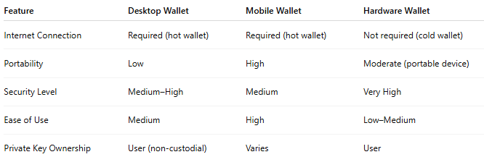

Feature | Desktop Wallet | Mobile Wallet | Hardware Wallet
Internet Connection | Required (hot wallet) | Required (hot wallet) | Not required (cold wallet)
Portability | Low | High | Moderate (portable device)
Security Level | Medium–High | Medium | Very High
Ease of Use | Medium | High | Low–Medium
Private Key Ownership | User (non-custodial) | Varies | User

🔐 Security Tips for Desktop Wallets:
# Source: AI Source: Provided by: [Data Path: Persons Table -> ID Column: 1, Name_En Column: Motasem Essam] -> From: [ChatGPT] on [1/21/2026]
- Encrypt your wallet file with a strong password.
- Keep your OS and antivirus software up to date.
- Back up your wallet data or recovery phrase regularly.
- Avoid using on public/shared computers.
- Consider pairing with a hardware wallet for extra security.

